2023 Annual Program Assessment Report Planning Sheet

for Undergraduate Degree Programs
NOT FOR SUBMISSION – Reports are collected online via Qualtrics

Note: The 2023 Annual Program Assessment Reports for Undergraduate Degree Programs will be collected online using Qualtrics. Submit your report in Qualtrics during the open reporting window – anytime from mid-December 2023 through February 2024, as fits your workflow.

Preparing for Your Program’s 2023 Assessment Report. This document contains a copy of the questions from the 2023 Annual Program Assessment Report. We encourage assessment coordinators and program leadership to familiarize themselves with these questions (slightly modified from 2022). In addition, assessment coordinators can use this planning sheet to develop their reports prior to submission to minimize time and effort when submitting the report in Qualtrics.

- ACE strongly encourages assessment coordinators to share/discuss their planning sheet with their department chair/school director/other program leadership prior to submission.
- The Office of Assessment for Curricular Effectiveness (ACE) is available to provide guidance, answer questions, and help programs complete this planning sheet.

Submitting Your Report in Qualtrics. This planning sheet is not to be used for submission; please copy and paste your responses from this document into the Qualtrics report form or enter the program’s assessment information directly into Qualtrics. Some questions on the planning sheet may appear differently in the online Qualtrics report format, as they are intended to collect further information on a topic and only appear, as applicable, on the Qualtrics report form. However, the wording and order of questions included here are consistent with what is included in Qualtrics. Please note that questions marked with asterisks (**) apply ONLY to degree programs reporting on multiple campuses. Additionally, hyperlinks are included throughout this planning sheet to view related resources on the ACE website.

In mid-December, each program’s assessment coordinator will receive an email from ACE (ace.office@wsu.edu) with a unique link to their Qualtrics report form; if you misplace your link or have questions, please contact ACE (ace.office@wsu.edu) for assistance. Note: You can start and stop working on your report in Qualtrics at any time using your unique link; the report form in Qualtrics will automatically save your work as you go and allow you to pick up where you left off from any computer or with any internet browser. See the following page for more information about the reporting process & timeline.

Questions? Please contact ACE at ace.office@wsu.edu.

Reporting Process Timeline: What to Expect
- Annual report planning sheet available to assessment coordinators and program leadership in early November 2023. Programs can use the planning sheet to familiarize themselves with the report questions and develop their report prior to submission.
  - ACE strongly encourages assessment coordinators to share/discuss their planning sheet with their department chair/school director/other program leadership prior to submission.
  - ACE is available to answer questions and help assessment coordinators complete the report; contact us for additional information.
- In mid-December 2023, each degree program’s assessment coordinator will receive an email from ACE (ace.office@wsu.edu) with a unique link to their Qualtrics report form.
- Assessment coordinators submit their report during the open reporting window (mid-Dec through Feb). You can copy and paste your responses from this planning sheet into Qualtrics.
- ACE staff will review the submitted report for content, clarity, consistency, and completeness, and will contact the assessment coordinator (or other program contact specified in the report) with any questions. Assessment coordinators (or another knowledgeable assessment contact) need to be available to answer questions until March 31, 2024.
- Assessment coordinators (or other program contact specified in the report) will be notified when their report is finalized and there is no need for further input.
- Finally, each program will receive a PDF copy of their final report from ACE in April 2024 for their continued use and archive. ACE will prepare WSU-wide and college summaries of annual assessment reports and meet with university and college leadership to discuss actions that can support assessment.

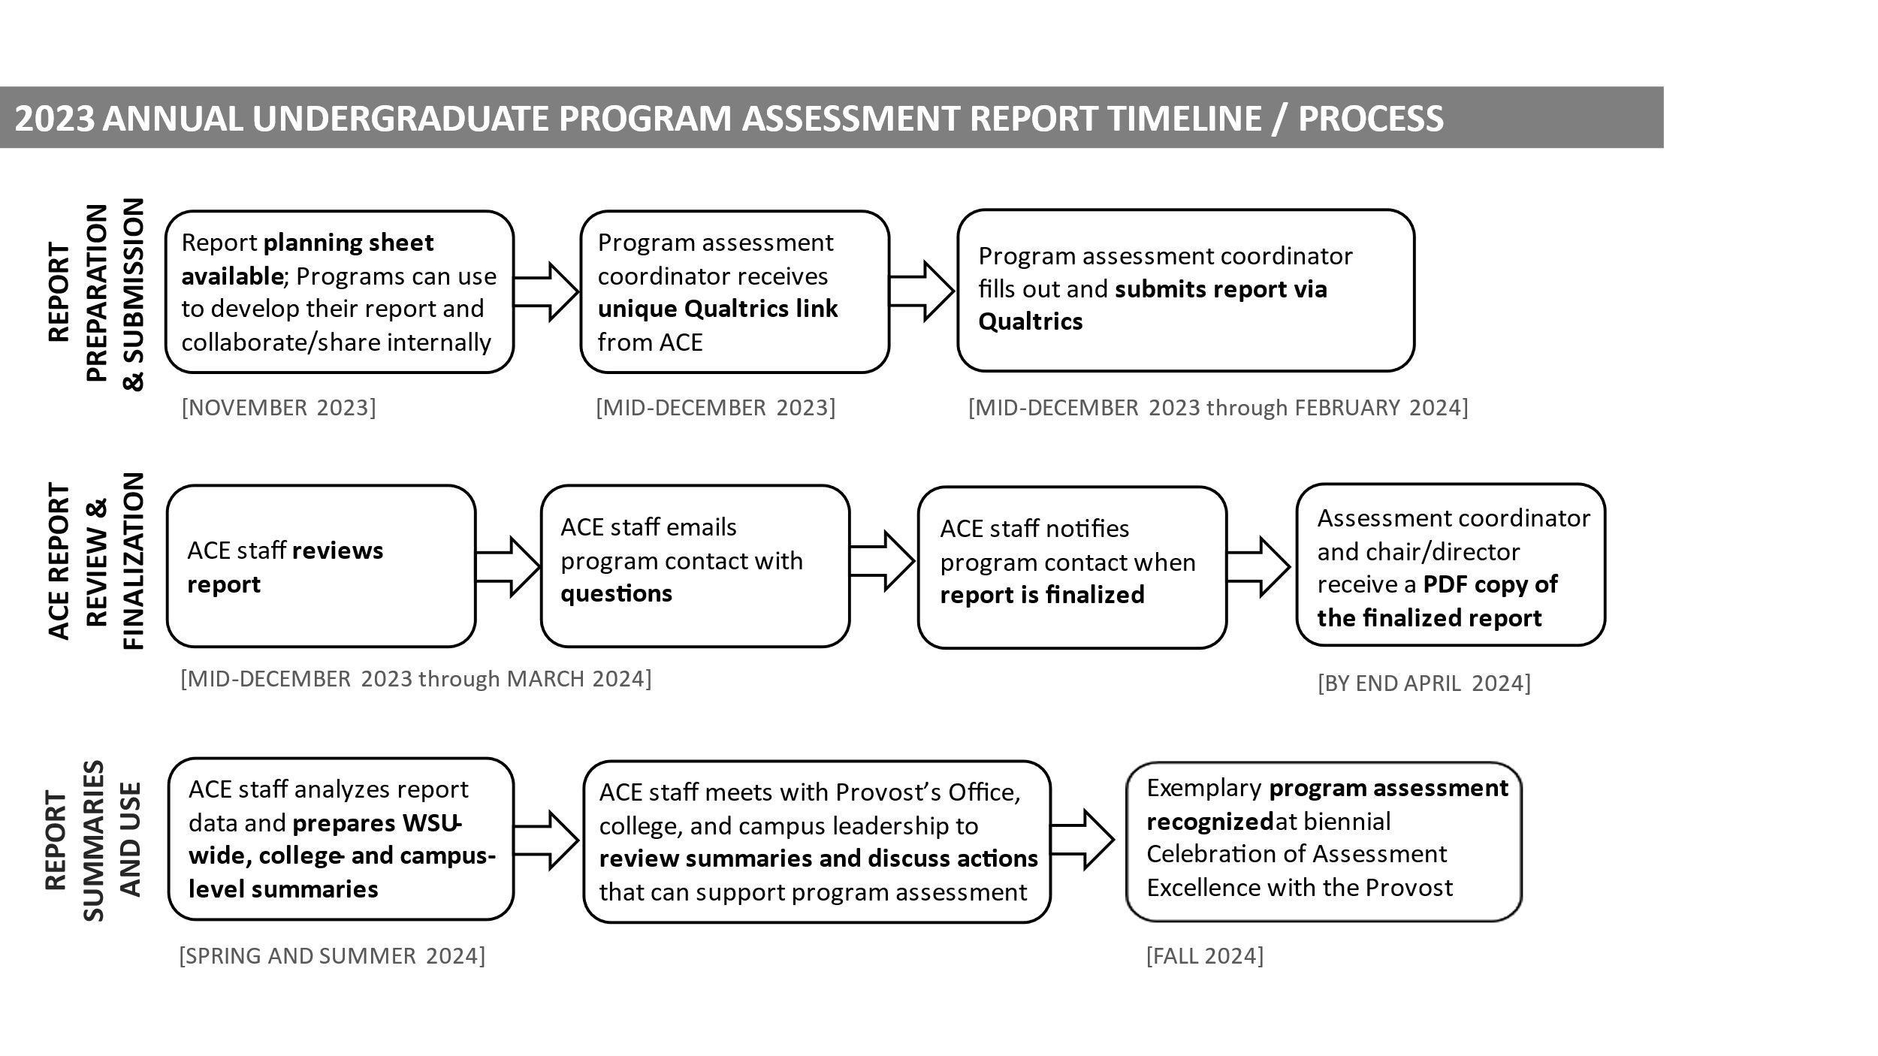

Annual Program Assessment Report for Undergraduate Degree Programs

Scope of Report: January 1 – December 31, 2023

Scope and Audience for this Report: This report provides a summary of the academic program assessment activities conducted by each undergraduate degree program and does not include all details or data. Unless otherwise noted, this report includes only activities occurring Jan 1 – Dec 31, 2023. Please provide clear and complete information -- with sufficient description for people outside your department and discipline, who are not familiar with your program assessment processes. ACE compiles portions of these annual program assessment reports, and collects examples, to share with college and institutional leadership. Undergraduate program assessment reports also help fulfill requirements to maintain WSU's regional accreditation under the Northwest Commission on Colleges and Universities (NWCCU).

Program Context

The information in this box is provided to programs via email with the annual report planning sheet, and will also be
pre-populated by ACE into the Qualtrics report form. (Note: ACE is providing this information based on data available in WSU’s student data warehouse, programs/assessment coordinators will not need to do anything to obtain this information.)

- Undergraduate Degree Title

- Campuses/Locations to Include in the Report

- Brief Description of Program Size

Department chair/school director/other program leadership name(s): ____________________

Program assessment coordinator name: ____________________

Report prepared by name(s): ____________________

Contact information for questions about this report: (Note: This person should be available to answer questions until March 31, 2024.)
Name: ____________________
Email: ____________________

Who contributed to/reviewed this report prior to submission? (select all that apply)
Note: In instances where someone fills multiple roles, please select each role that applies.
- Department chair/school director  - Undergraduate studies director  - Other program leadership role  (please specify) ____________  - Undergraduate studies, assessment, or similar committee  - Other role (please specify) ____________  - None of the above | - **One or more Pullman faculty  - **One or more Spokane faculty  - **One or more Tri-Cities faculty  - **One or more Vancouver faculty  - **One or more Everett faculty  - **One or more Bremerton faculty  - **One or more faculty that teaches for Global Campus

Optional comments on your program’s context: (e.g. changes to program assessment infrastructure or leadership, extension of the degree to another campus, creation of new majors/options, etc.)

Section A. Key Program Assessment Elements

Program-level student learning outcomes assessment is a process of faculty identifying what students should be able to do and know by the end of an academic program, measuring progress toward meeting those learning outcomes, and using that information to inform decision-making about teaching, learning, and curricula. In this context, program-level assessment (see graphic below) begins with program-level student learning outcomes (SLOs) and questions about student learning in the curriculum. After reviewing the program’s curriculum map indicating where particular SLOs are highlighted in the curriculum, faculty identify direct and indirect measures to gather evidence related to student learning for their majors. The evidence is analyzed, discussed by the faculty, and used to inform program decisions to support student learning, including those about instruction, assignments, the curriculum, and dialog about teaching and learning.

Section A of this report focuses on key elements for program-level assessment: (1) program-level SLOs, (2) curriculum maps, (3) assessment plans, (4) direct measures of student learning, (5) indirect measures of student learning, and (6) use of assessment to inform decisions/actions.

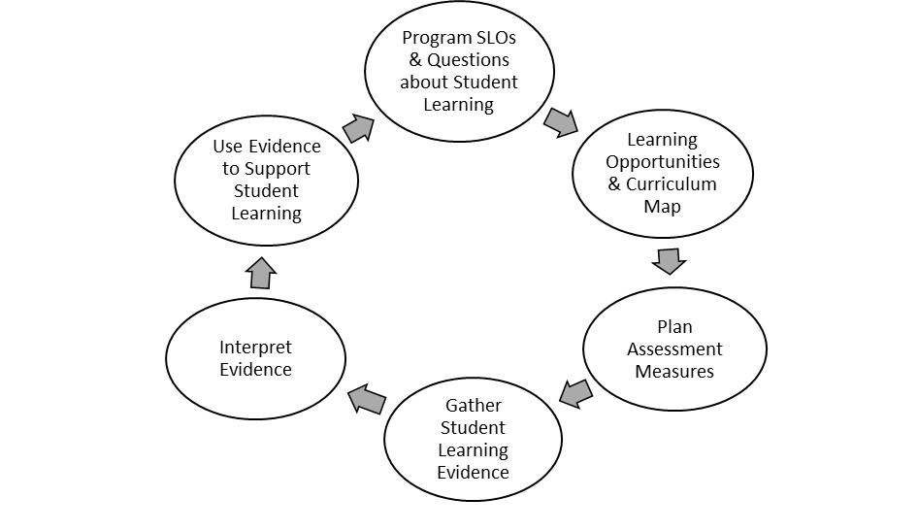

1. Program-level Student Learning Outcomes

Program-level student learning outcomes (SLOs) represent core skills and knowledge that students are expected to achieve as they complete a program (e.g. core courses and electives for the major).

Select the option that best describes the status of your program’s program-level student learning outcomes.
- Our program has program-level SLOs, and they are up to date
- Our program has program-level SLOs, but some SLOs are under or in need of revision
- Our program has had program-level SLOs, but they are substantially out of date (i.e. the program-level SLOs are no longer relevant)
- Our program does not have program-level SLOs

Optional comments on your program’s program-level student learning outcomes:

Please attach your program’s program-level student learning outcomes. Note: On the attachment, please include the date, if known, that program SLOs were last reviewed by the majority of faculty who teach.

2. Curriculum Map

A curriculum map is a matrix aligning program-level SLOs with the courses for a degree program or major.

Select the option that best describes the status of your program’s curriculum map.
- Our program has a curriculum map, and it is up to date (i.e. the map reflects current program SLOs and courses)
- Our program has a curriculum map, but it is under or in need of minor revision (i.e. some program-level SLOs and/or courses are in need of updating on the map)
- Our program has had a curriculum map, but it is substantially out of date (i.e. the map is no longer relevant or many program-level SLOs and/or courses are in need of updating on the map)
- Our program does not have a curriculum map

Optional comments on your program’s curriculum map:

Please attach your program’s curriculum map. Note: On the attachment, please include the date, if known, that your program’s curriculum map was last reviewed by the majority of faculty who teach.

3. Assessment Plan

An assessment plan articulates a program’s process and timeline for conducting program learning outcomes assessment activities, and for collecting, analyzing, and using assessment data.

Did your program have an assessment plan articulating the intended process and timeline for key program learning outcomes assessment activities during the past year (Jan 1 – Dec 31)?
- Yes, our program had an assessment plan with an intended timeline for most key activities during the past year
- Yes, our program had an assessment plan without an intended timeline for most key activities during the past year (includes plans with out of date timelines, if the plan generally reflects most key activities during the past year)
- No, our program did not have an assessment plan for most key activities during the past year or had a plan that is substantially out of date (i.e. does not generally reflect most key activities during the past year)

Optional comments on your program’s assessment plan:

Please attach your program’s assessment plan. Note: On the attachment, please include the date, if known, that your program’s assessment plan was last updated.

4.A. Direct Measures

A direct measure is an assessment (by faculty or other professionals) of student work products or performances that provides demonstrated evidence of program-level student learning outcomes (i.e. skills and knowledge).

During the past year (Jan 1 – Dec 31), did your program collect a direct measure providing evidence of student performance on program-level student learning outcomes for your majors for use in program-level assessment?
- Yes, our program collected one or more direct measures during the past year
- No, our program did not collect a direct measure during the past year

Which type(s) of direct measure(s) were collected for your majors for use in program-level assessment during the past year (Jan 1 – Dec 31)? (select all that apply)
- Evaluation of student coursework using a program rubric, rating scale, or similar tool (e.g. by course instructors, other program faculty, industry partners, and/or other professionals)  - Evaluation of student intern/trainee performance on skills and knowledge by internship supervisor, preceptor, or employer | - Course exam results/scores  - National exam results/scores (e.g. certification, licensure, or other standardized test)  - Other direct measure (please specify) ____________

Optional comments on your program’s direct measure(s):

4.B. Direct Measures Near End of Curriculum

A direct measure collected near the end of the curriculum provides demonstrated evidence of student performance on program-level student learning outcomes as students are completing the program/curriculum. Note: Direct measures collected near the end of the curriculum may include seniors and/or juniors, as best fits the program context.

During the past year (Jan 1 – Dec 31), did your program collect a direct measure near the end of the curriculum providing evidence of student performance on program-level student learning outcomes for your majors as they were completing the curriculum for use in program-level assessment?
- Yes, our program collected one or more direct measures near the end of the curriculum during the past year
- No, our program did not collect a direct measure near the end of the curriculum during the past year

Of the direct measure types previously selected in Part 4.A. Direct Measures, which type(s) of direct measure(s) were collected near the end of the curriculum for your majors for use in program-level assessment during the past year
(Jan 1 – Dec 31)? (select all that apply)
- Evaluation of student coursework using a program rubric, rating scale, or similar tool (e.g. by course instructors, other program faculty, industry partners, and/or other professionals)  - Evaluation of student intern/trainee performance on skills and knowledge by internship supervisor, preceptor, or employer | - Course exam results/scores  - National exam results/scores (e.g. certification, licensure, or other standardized test)  - Other direct measure (please specify) ____________

Optional comments on your program’s direct measure(s) collected near the end of the curriculum:

**4.C. Multi-Campus Assessment: Direct Measures Near End of Curriculum

In multi-campus degrees, assessment must include students, courses, and faculty from each campus/location offering the degree. WSU expects programs offered on multiple campuses to collect measures of student learning from majors near the end of the curriculum on each campus offering the degree.

Of the direct measure types previously selected in Part 4.B. Direct Measures Near End of Curriculum, please indicate which type(s) of direct measure(s) were collected near the end of the curriculum for your majors on each campus/ location in this report for use in program-level assessment during the past year (Jan 1 – Dec 31). (select all that apply)

Note: The appropriate multiple-choice response options and campuses will be automatically populated in Qualtrics.

Optional comments on your program’s direct measure(s) collected near the end of the curriculum for your majors on each campus/location in this report:

5.A. Indirect Measures

Indirect measures include perspectives, input, and other indicators (from students or others) that provide evidence related to program-level student learning outcomes (e.g. perceived gains or confidence in specific skills or knowledge, motivation, satisfaction, the availability or quality of learning opportunities, student progress, etc.). Indirect measures can be helpful in informing decision-making related to changes in instruction or the curriculum, but they don’t provide demonstrated evidence of what students have learned – or the skills and knowledge that students have achieved.

During the past year (Jan 1 – Dec 31), did your program collect an indirect measure providing evidence related to program-level student learning outcomes for your majors for use in program-level assessment?
- Yes, our program collected one or more indirect measures during the past year
- No, our program did not collect an indirect measure during the past year

Which type(s) of indirect measure(s) were collected for your majors for use in program-level assessment during the past year (Jan 1 – Dec 31)? (select all that apply)
Student Perspectives and Experience:
- Focus groups  - Interviews (e.g. exit or other)  - Student self-assessment or reflection | - Survey, alumni  - Survey, student (e.g. exit, NSSE, or other)  - Other (please specify) ____________________
Professional Perspectives and Input:
- Advisory board (providing input on program)  - Faculty review of curriculum, SLOs, syllabi, or assignment prompts  - Feedback from external accreditors | - Internship supervisor, preceptor, or employer feedback on student activities, motivation, or behavior  - Survey, employer (providing professional input on program)
- Other (please specify) ____________________
Indicators of Student Progress / Success in the Curriculum:
- Course grades  - Enrollment data (e.g. course taking patterns, retention)  - Graduation data (e.g. time to degree, job placement) | - Participation rates (research, internship, service learning, study abroad, etc.)  - Other (please specify) ____________________

Optional comments on your program’s indirect measure(s):

5.B. Indirect Measures Near End of Curriculum

An indirect measure collected near the end of the curriculum provides evidence related to program-level student learning outcomes from perspectives, input, or other indicators (from students or others) as students are completing the program/curriculum. Note: Indirect measures collected near the end of the curriculum may include seniors and/or juniors, as best fits the program context.

During the past year (Jan 1 – Dec 31), did your program collect an indirect measure near the end of the curriculum providing evidence related to program-level student learning outcomes for your majors as they were completing the curriculum for use in program-level assessment?
- Yes, our program collected one or more indirect measures near the end of the curriculum during the past year
- No, our program did not collect an indirect measure near the end of the curriculum during the past year

Of the indirect measure types previously selected in Part 5.A. Indirect Measures, which type(s) of indirect measure(s) were collected near the end of the curriculum for your majors for use in program-level assessment during the past year (Jan 1 – Dec 31)? (select all that apply)
Student Perspectives and Experience:
- Focus groups  - Interviews (e.g. exit or other)  - Student self-assessment or reflection | - Survey, alumni  - Survey, student (e.g. exit, NSSE, or other)  - Other (please specify) ____________________
Professional Perspectives and Input:
- Advisory board (providing input on program)  - Faculty review of curriculum, SLOs, syllabi, or assignment prompts  - Feedback from external accreditors | - Internship supervisor, preceptor, or employer feedback on student activities, motivation, or behavior  - Survey, employer (providing professional input on program)
- Other (please specify) ____________________
Indicators of Student Progress / Success in the Curriculum:
- Course grades  - Enrollment data (e.g. course taking patterns, retention)  - Graduation data (e.g. time to degree, job placement) | - Participation rates (research, internship, service learning, study abroad, etc.)  - Other (please specify) ____________________

Optional comments on your program’s indirect measure(s) collected near the end of the curriculum:

**5.C. Multi-Campus Assessment: Indirect Measures Near End of Curriculum

In multi-campus degrees, assessment must include students, courses, and faculty from each campus/location offering the degree. WSU expects programs offered on multiple campuses to collect measures of student learning from majors near the end of the curriculum on each campus offering the degree.

Of the indirect measure types previously selected in Part 5.B. Indirect Measures Near End of Curriculum, please indicate which type(s) of indirect measure(s) were collected near the end of the curriculum for your majors on each campus/ location in this report for use in program-level assessment during the past year (Jan 1 – Dec 31). (select all that apply)

Note: The appropriate multiple-choice response options and campuses will be automatically populated in Qualtrics.

Optional comments on your program’s indirect measure(s) collected near the end of the curriculum for your majors on each campus/location in this report:

6.A. Use of Assessment: Decisions/Actions Informed by Any Program Assessment (Direct and/or Indirect)

Program assessment activities and data are intended to regularly inform faculty reflection and discussion about effective teaching, learning, and curricula, and ultimately inform decision-making to support student learning. Decisions/actions may include intentionally choosing to continue current effective practices, building on the program’s existing strengths, and/or making changes to the program. Use of assessment can occur at any point in the process of collecting, analyzing, or discussing direct and/or indirect assessment.

Over the course of the past year (Jan 1 – Dec 31), did this program make a decision/take an action that was informed by direct and/or indirect assessment? Note: A decision/action in the past year may have been informed by assessment collected in previous years. It is not expected that programs complete a particular assessment cycle in one year.
- Yes | - No

Please select the type(s) of decision(s) made/action(s) taken over the course of the past year (Jan 1 – Dec 31) that were informed by direct and/or indirect assessment. (select all that apply)
- updating course content  - updating or developing assignments  - updating instructional methods  - course enrollment changes (e.g. course capacity)  - course prerequisite change  - new course development  - changes in advising  - changes to policies/procedures | - degree requirement change  - degree course sequencing change  - updating or developing program SLOs  - updating an assessment measure  - developing a new assessment measure  - updating or developing benchmarks/targets  - faculty/TA professional development
- decision to continue current effective curriculum, instruction, and/or assignments (please specify) ____________________
- decision to continue current effective assessment processes (please specify) ____________________

- other types of decisions/actions influenced by assessment (please specify) ____________________

Optional comments on decision/actions informed by program assessment:

6.B. Use of Assessment: Decisions/Actions Informed by Assessment of a Specific Program-level SLO

While all program assessment activities and data can provide useful information for program improvement, using assessment of specific program-level student learning outcomes (SLOs) to inform decision-making is crucial to supporting quality undergraduate curricula and student achievement. Note: While all program-level SLOs do not need to be measured annually, program-level SLOs should be measured/reviewed within a reasonable cycle.

In an assessment cycle for a specific program-level SLO, a degree program assesses student learning related to that SLO using direct and/or indirect measures and uses the data to inform program decision-making to support student learning, including decisions/actions related to curriculum, instruction, assignments; some decisions may focus on improving program assessment processes. Decisions/actions may include intentionally choosing to continue current effective practices, building on the program’s existing strengths, and/or making changes to the program.

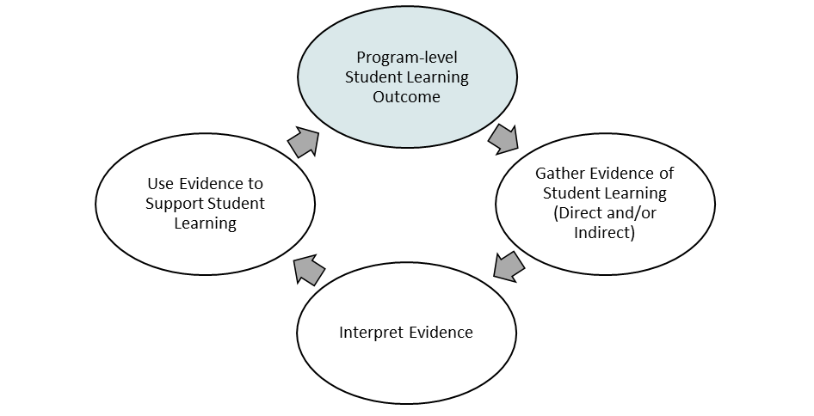

Over the course of the past year (Jan 1 – Dec 31), did this program make a decision/take an action that was informed by direct and/or indirect assessment of a specific program-level SLO? Note: A decision/action in the past year may have been informed by assessment data collected in previous years. It is not expected that programs complete an assessment cycle every year, or that programs complete an entire assessment cycle for a particular SLO in one year.
[see sample entries for guidance]

- Yes, our program made a decision/took an action in the past year that was informed by assessment of a specific program-level SLO
- No, our program did not make a decision/take an action in the past year that was informed by assessment of a specific program-level SLO

6.B. Use of Assessment: Decisions/Actions Informed by Assessment of a Specific Program SLO, continued

IF YES: In the spaces below, provide ONE example that illustrates the cycle of how your program used assessment of a specific program-level SLO to inform decision-making, by describing the most noteworthy decision/action in the past year (Jan 1 – Dec 31) related to curriculum, instruction, assignments, faculty/TA development, and/or program assessment processes and how that decision/action was informed by assessment of a program-level SLO.

Example of Decision/Action Informed by Assessment of a Specific Program SLO
[see sample entries for guidance and recommended level of detail]

Program-level SLO Assessed: ____________________________________
(Please specify the specific program-level SLO assessed in this assessment cycle example)

Please select the category that describes the most noteworthy decision/action in the past year (Jan 1 – Dec 31). (select all that apply)
- Change to curriculum, instruction, or assignments  - Change to program assessment processes  - Decision/action related to faculty/TA development | - Decision to continue current effective curriculum, instruction, or assignments  - Decision to continue current effective assessment processes  - Other type of decision/action (please specify) _______________

Assessment Measure(s) Providing Evidence for Decision/Action
Replace this text with a brief description of the direct and/or indirect assessment measure(s) used to assess this program-level SLO, including how and when (e.g. specific semesters) they were collected. Where possible, indicate the number of students and faculty included in the assessment measure(s).
Assessment Results that Informed Decision/Action: What Was Learned
Replace this text with a brief summary of the SLO assessment results that informed the decision/action (i.e. what your program learned from the assessment).
Decision/Action in the Past Year (Jan 1 – Dec 31)
Replace this text with a brief description of the decision/action related to curriculum, instruction, assignments, faculty/TA development, program assessment processes and/or other decision-making.

IF NO: In the spaces below, provide an example that indicates where the program is in the assessment cycle for ONE program-level SLO.

Example of Assessment Cycle Process for a Specific Program-level SLO
[see sample entries for guidance and recommended level of detail]

Program-level SLO Assessed: ____________________________________
(Please specify the specific program-level SLO in this assessment cycle example or indicate “not applicable” in instances where a program has not yet assessed a specific program-level SLO)

Assessment Measure(s)
Replace this text with a brief description of the direct and/or indirect assessment measure(s) used to assess this program-level SLO, including how and when (e.g. specific semesters) they were collected, or indicate if an assessment measure has not yet been collected to assess a program-level SLO. Where possible, indicate the number of students and faculty included in the assessment measure(s).
Assessment Results: What Was Learned
Replace this text with a brief summary of the SLO assessment results (i.e. what your program learned from the assessment) or indicate if assessment data has not yet been analyzed/interpreted.
Next Steps
Replace this text with a brief description of how SLO assessment data will be collected, analyzed, and/or shared with faculty and used to inform program decision-making.

Section B. Focus on Program-level SLO Achievement Near End of Curriculum

An effective system of program-level assessment includes direct measures near the end of the curriculum, providing programs with information about student achievement of program-level student learning outcomes (SLOs) as majors are completing the curriculum. While all program-level SLOs do not need to be measured annually, student achievement of program-level SLOs near the end of the curriculum should be measured/reviewed within a reasonable cycle. Note: Student achievement of program-level SLOs near the end of the curriculum may include seniors and/or juniors, as best fits the program context.

Section B of this report focuses on achievement of program-level SLOs by your majors near the end of the curriculum. SLO achievement summary information helps programs demonstrate academic strengths, as well as set priorities for improvement, and supports WSU’s strategic planning and mission fulfillment.

Achievement of Program-level SLOs Near End of Curriculum
[see sample entries for guidance]

In the past year (Jan 1 – Dec 31), did program faculty review/discuss representative assessment results from one or more direct measures of student learning for your majors near the end of the curriculum that indicated student achievement of at least one program-level SLO? Note: Faculty may have reviewed/discussed results from an assessment measure collected in previous years. It is not expected that programs complete a particular assessment cycle in one year.

- Yes, our program reviewed/discussed representative assessment results in the past year, from one or more direct measures near the end of the curriculum, that indicated SLO achievement for our majors
- No, our program did not review/discuss representative assessment results in the past year, from one or more direct measures near the end of the curriculum, that indicated SLO achievement for our majors

Note for Multi-Campus Degrees: Section B of this report is intended to consider program-level SLO achievement that is representative of the degree as a whole. (While WSU expects programs offered on multiple campuses to collect measures of student learning for students on each campus offering the degree, it is not necessary here to report SLO achievement separately for each campus.)

Achievement of Program-level SLOs Near End of Curriculum, continued

IF YES: [see sample entries for guidance and recommended level of detail]
Note: Programs should report program-level SLO achievement based on the faculty-determined expectations that fit their unique context. WSU respects program autonomy in deciding the most useful approach to guide improvement in their programs and courses.

Please indicate the number of program-level SLOs where
faculty who teach reviewed/discussed student achievement
near the end of the curriculum:
Of these, please indicate the number of program-level SLOs
where student achievement near the end of the curriculum
met or exceeded program faculty expectations:

Please list the program-level SLOs where student achievement near the end of the curriculum met or exceeded program faculty expectations.

Please briefly describe the direct measure(s) near the end of the curriculum that indicated student achievement of program-level SLOs, including how and when (e.g. specific semesters) the measures were collected, how program faculty reviewed the data/results, and how the data/results provided adequate representation of your students. Note: Assessing the entire group of students near the end of the curriculum (a census), will accurately reflect the variations and diversity represented within that population as all students are included. Alternatively, assessing a subset of students near the end of the curriculum (a sample) provides adequate representation when the sample parallels the key variables/characteristics of the population, such as sex, age, campus, major/option, or other key variables/characteristics of interest depending on the context of a particular program. [see sample entries for guidance and recommended level of detail]

Program-level Contribution to Achievement of the WSU Undergraduate Learning Goals. All undergraduates are expected to achieve the WSU Undergraduate Learning Goals, which identify core skills and knowledge that students should develop through their undergraduate studies. Through the achievement of program-level student learning outcomes, students demonstrate specialized knowledge and skills in the discipline, as well as achievement of some WSU Undergraduate Learning Goals (as appropriate to the disciplinary focus), through depth of study within the chosen academic field. The WSU Undergraduate Learning Goals are expressed broadly so as to frame study in the major as well as general education.

Based on the program SLOs you listed above, where achievement near the end of the curriculum met or exceeded faculty expectations, which of the following WSU Undergraduate Learning Goals did your students achieve? (select all that apply) [see sample entries - appendix for guidance related to this question]
- Critical and Creative Thinking  - Quantitative Reasoning | - Information Literacy  - Scientific Literacy | - Communication  - Diversity
- Depth, Breadth, and Integration of Learning |  | - None of the above

Optional comments on student achievement of program-level SLOs near the end of the curriculum:

IF NO: [see sample entries for guidance and recommended level of detail]

Please indicate where your program is in this process and any next steps.

Section C. Faculty Involvement

Faculty involvement in program assessment can increase shared faculty understanding of the curriculum, teaching, and learning, and offer ways to think about student learning in the curriculum and how to support it in their classes.

Section C of this report includes assessment communication and faculty engagement in program assessment activities.

1. Assessment Communication

Program faculty and leadership play critical roles in discussing assessment, which can contribute to decisions about curriculum, instruction, professional development, and assessment processes.

In the past year (Jan 1 – Dec 31), how often did the following groups discuss program-level assessment?
 | More than once  per semester | Once per  semester | Once per  year | Did not occur  in past year
Program leadership (chair, director, other)
Assessment, curriculum, or similar committee
Majority of faculty who teach

**Please briefly describe how faculty who teach on each campus/location in this report were included in discussions of program-level assessment (e.g. as part of a retreat or meeting that includes faculty from all campuses). Indicate if faculty who teach on a particular campus/location did not participate in discussions of program-level assessment.

Optional comments on the discussion of your program-level assessment:

2. Engagement in Program Assessment Activities

Faculty who engage in program assessment activities conduct significant work toward continuous improvement of curriculum, instruction, and assessment practices. In many programs, clinical faculty, instructors, and graduate teaching assistants contribute to program assessment activities.

Please select the type(s) of program assessment activities that two or more faculty members engaged in during the past year (Jan 1 – Dec 31). (select all that apply)
Note: It is not expected that programs will engage in all of these activities every year. Additionally, an activity may fit into more than one of the options provided below (i.e. a curriculum mapping retreat that results in updating SLOs).
- updating or developing program SLOs  - curriculum mapping  - updating or developing an assessment measure  - norming on a program rubric  - evaluating student work for program assessment  - none of the above | - reviewing/discussing assessment data/findings  - making decisions informed by assessment data  - faculty/TA professional development  - other program assessment activity (please specify) ____________________

**Please briefly describe how faculty who teach on each campus/location in this report engaged in program assessment activities (e.g. as part of a retreat or regular meeting that includes faculty from all campuses). Indicate if faculty who teach on a particular campus/location did not participate in assessment activities.

Optional comments on faculty engagement in assessment activities:

Section D. Recognition of Assessment Excellence (Optional)

ACE and the Office of the Provost host a Celebration of Assessment Excellence, typically every other year, honoring WSU undergraduate programs with exemplary assessment practices. The Fall 2024 Celebration of Assessment Excellence will again focus on recognizing undergraduate degree programs that, as appropriate to their context, have used assessment data from direct measures near the end of the curriculum, to improve curriculum, instruction, assignments, and/or faculty/TA development, where faculty have participated in the decision and/or implementation.

Section D of this report includes an optional space for programs to describe ‘an example of use of direct assessment near the end of the curriculum to support decision-making’ for consideration for the Fall 2024 Celebration of Assessment Excellence.

Given the emphasis on use of direct assessment near the end of the curriculum described above, would your program like to be considered for recognition at the Fall 2024 Celebration of Assessment Excellence?
- Yes | - No

IF YES: Given the emphasis on use of direct assessment near the end of the curriculum described above, please indicate if you would like the example that you described in Section A, Part 6.B. Use of Assessment: Decisions/Actions Informed by Assessment of a Specific Program-level SLO to be considered for recognition in 2024?
- Yes, the example described in Section A, Part 6.B. includes use of a direct measure of a specific program-level SLO collected near the end of the curriculum to inform decisions/actions related to curriculum, instruction, assignments, and/or faculty/TA development, where faculty members have participated in the decision and/or implementation
- No, our program would like to provide a different example to be considered for recognition

IF YES: Is there any additional information that you would like to provide about the example described in Section A, Part 6.B. (such as how faculty members participated in the decision and/or implementation)? If so, please describe.

IF NO: In the spaces below, provide ONE example that illustrates the cycle of how your program used direct assessment of a specific program-level SLO collected near the end of the curriculum to inform decision-making, by describing the most noteworthy decision/action in the past year (Jan 1 – Dec 31) related to curriculum, instruction, assignments, and/or faculty/TA development and how that decision/action was informed by assessment of a program-level SLO (including how faculty members participated in the decision and/or implementation).

Example of Decision/Action Informed by Direct Assessment of a Specific Program SLO Near End of the Curriculum

Program-level SLO Assessed: ____________________________________
(Please specify the specific program-level SLO assessed in this assessment cycle example)

Assessment Measure(s) Providing Evidence for Decision/Action
Replace this text with a brief description of the direct assessment measure(s) used to assess this program-level SLO. Where possible, indicate the number of students and faculty included in the assessment measure(s). Please also describe any applicable indirect measures aligned with this program SLO and decision/action.
Assessment Results that Informed Decision/Action: What Was Learned
Replace this text with a brief summary of the SLO assessment results that informed the decision/action (i.e. what your program learned from the assessment).
Decision/Action in the Past Year (Jan 1 – Dec 31)
Replace this text with a brief description of the decision/action related to curriculum, instruction, assignments, and/or faculty/TA development, including how faculty members participated in the decision and/or implementation

Section E. Other (Optional)

Section E of this report includes an optional space for programs to describe a particular success story, or any other assessment or related activities faculty engaged in during the past year (Jan 1 – Dec 31), such as assessment of service courses, UCORE, minors, interdisciplinary programs, etc.

Does your program have a success story that you’d like to share? If so, please describe.

In the space below, please describe any other assessment or related activities your program faculty have engaged in during the past year (Jan 1 – Dec 31).

